**Eid al-Fitr**

**What is Eid?**

Eid literally means a «festival» or «feast» in Arabic. There are two major eids in the Islamic calendar per year – Eid al-Fitr earlier in the year and Eid al-Adha later.

**Why is Eid celebrated twice a year?**

The two Eids recognize, celebrate and recall two distinct events that are significant to the story of Islam.

**How do Muslims celebrate Eid al-Fitr?**

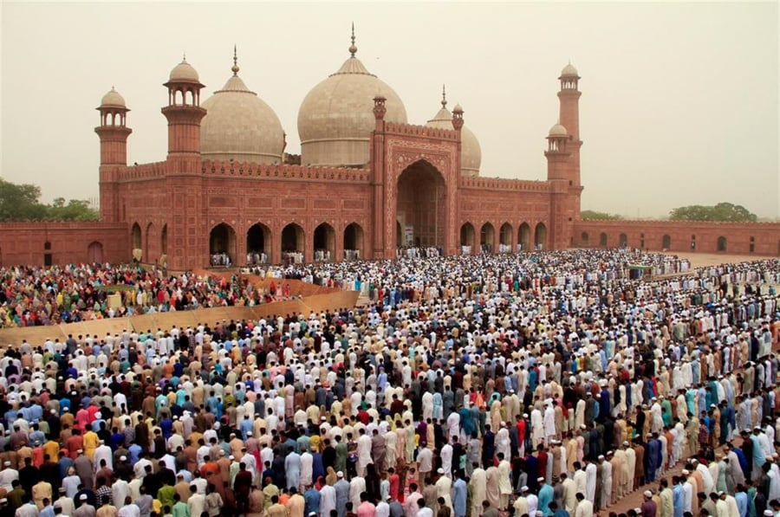Eid al-Fitr features two to three days of celebrations that include special morning prayers. People greet each other with «Eid Mubarak,» meaning «Blessed Eid» and with formal embraces. Sweet dishes are prepared at home and gifts are given to children and to those in need. In addition, Muslims are encouraged to forgive and seek forgiveness. Practices vary from country to country.

In many countries with large Muslim populations, Eid al-Fitr is a national holiday. Schools, offices and businesses are closed so family, friends and neighbors can enjoy the celebrations together. In the U.S. and the U.K., Muslims may request to have the day off from school or work to travel or celebrate with family and friends.

**How do Muslims celebrate Eid al-Adha?**

The other festival, Eid al-Adha, is the «feast of the sacrifice.» It comes at the end of the Hajj, an annual pilgrimage by millions of Muslims to the holy city of Mecca in Saudi Arabia that is obligatory once in a lifetime, but only for those with means.

Eid al-Adha recalls the story of how God commanded Ibrahim to sacrifice his son Ismail as a test of faith.

**When are they celebrated?**

Eid al-Fitr is celebrated on the first day of the 10th month in the Islamic calendar.

Eid al-Adha is celebrated on the 10th day of the final month in the Islamic calendar.

The Islamic calendar is a lunar calendar, and dates are calculated based on lunar phases.

**What is the spiritual meaning of Eid al-Fitr?**

Eid al-Fitr, as it follows the fasting of Ramadan, is also seen as a spiritual celebration of Allah’s provision of strength and endurance.

Amid the reflection and rejoicing, Eid al-Fitr is a time for charity, known as Zakat al-Fitr.